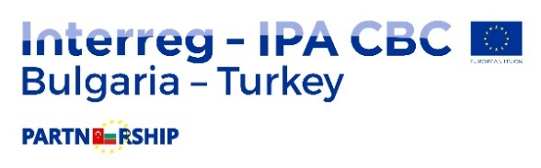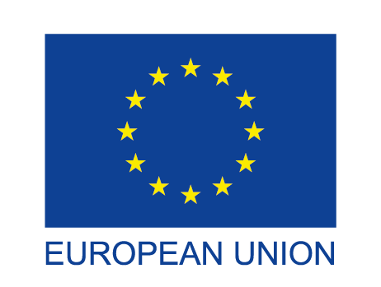

PROJECT “Cross Border Maritime Environment Protection” (CbMEP)
СВ005.2.12.015

On July 24, 2019 started the implementation of the Cross Border Maritime Environment Protection (CbMEP) project, Priority Axis 1. Environment, Specific Objective 1.2: Improving the capacity for nature protection, sustainable use and management of common natural resources through cooperation initiatives in the cross-border area. The Maritime Administration Executive Agency, through the Maritime Administration Directorate – Burgas is the Lead Partner. Partner in the project from the Republic of Turkey is Demirköy District Governorate.
The project was approved and Subsidy Contract RD 02-29-184/23.07.2019 for financing was concluded in the framework of the Second Call for Proposals under the CBC programme "Interreg -IPA CBC Bulgaria -Turkey" for the year 2014 -2020 under the Instrument for Pre-accession Assistance (IPAII) “
The activities of the project aim to develop and implement integrated and coordinated cross-border initiatives for the prevention and reduction of the risk of pollution and the protection of the nature of the marine and coastal zone of the Black Sea coast of Burgas and Demirkyoy district. The joint activities will improve the risk management and the coordination between the institutions of the cross-border region of Bulgaria and Turkey for the prevention of the marine environment in the event of spills and coastal pollution and in the event of emergencies with vessels. A Joint Action plan and the development of Standard Operational Procedures (SOPs) for response in the event of an emergency spill from vessels or shore sources are foreseen. The Joint Bulgarian-Turkish Emergency Squad formed under the project will ensure timely containment of spills and prevention of pollution of the sea and the coastline of Burgas and Kirklareli districts from oil spills and other waste from ships and coastal sources.
The total budget amount is € 399,915.09, of which € 339,927.82 are from IPA and € 59,987.27 - from national public co-financing provided by the two partner states Bulgaria and Turkey.

